Tristan Izlar

COP2360 C# Programming I

## Module 2 - ASSIGNMENT Chapter 4 - Problem 5: Distance Converter

SCREENSHOT:

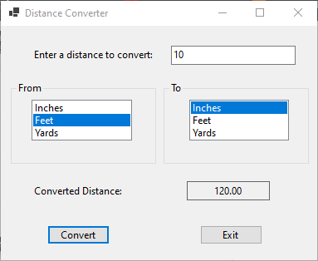

CODE:

using System;

using System.Collections.Generic;

using System.ComponentModel;

using System.Data;

using System.Drawing;

using System.Linq;

using System.Text;

using System.Threading.Tasks;

using System.Windows.Forms;

namespace Distance_Converter

{

public partial class Form1 : Form

{

public Form1()

{

InitializeComponent();

}

private void exitButton_Click(object sender, EventArgs e)

{

this.Close();

}

private void convertButton_Click(object sender, EventArgs e)

{

//declare user input variable, the conversion calculation value, and the user conversion choices

double userInput, conversionValue;

string fromChoice, toChoice;

//checking if the user entered a valid number into textbox

if (!(double.TryParse(userInputBox.Text, out userInput)))

{

MessageBox.Show("Please enter a vaild number to be converted.");

userInputBox.Focus();

}

else

{

//checking if the user selected a "From" option and warning them if not

if (fromListBox.SelectedIndex != -1)

{

//assigning the user from selection to a variable

fromChoice = fromListBox.SelectedItem.ToString();

//checking if the user selected a "To" option and warning them if not

if (toListBox.SelectedIndex != -1)

{

//assigning the user to selection to a variable

toChoice = toListBox.SelectedItem.ToString();

//if-else-if used for conversions and to check if a possible conversion option was selected (in the last else if)

if (fromChoice == "Inches" && toChoice == "Feet")

{

conversionValue = userInput / 12;

convertedResultsLabel.Text = conversionValue.ToString("n2");

}

else if (fromChoice == "Inches" && toChoice == "Yards")

{

conversionValue = userInput / 36;

convertedResultsLabel.Text = conversionValue.ToString("n2");

}

else if (fromChoice == "Feet" && toChoice == "Inches")

{

conversionValue = userInput * 12;

convertedResultsLabel.Text = conversionValue.ToString("n2");

}

else if (fromChoice == "Feet" && toChoice == "Yards")

{

conversionValue = userInput / 3;

convertedResultsLabel.Text = conversionValue.ToString("n2");

}

else if (fromChoice == "Yards" && toChoice == "Inches")

{

conversionValue = userInput * 36;

convertedResultsLabel.Text = conversionValue.ToString("n2");

}

else if (fromChoice == "Yards" && toChoice == "Feet")

{

conversionValue = userInput * 3;

convertedResultsLabel.Text = conversionValue.ToString("n2");

}

else if (fromChoice == toChoice)

{

MessageBox.Show("You selected the same unit to convert between, please try again.");

}

}

else

{

MessageBox.Show("Please select a unit to convert to.");

}

}

else

{

MessageBox.Show("Please select a unit to convert from.");

}

}

}

}

}

# //Collaboration Statement: I worked alone.